Name: Sandesh Varma                                                                     Date: 15/09/2025

Roll No: CH.EN.U4CSE22078

Experiment No: 6

___________________________________________________________________

Aim: To implementation of intermediate code generation.

**Algorithm:**

1. Take the parse tree tokens from the syntax analyser.

2. Generate intermediate code using temp variable

3. Assign the final temp variable to initial variable

Code:

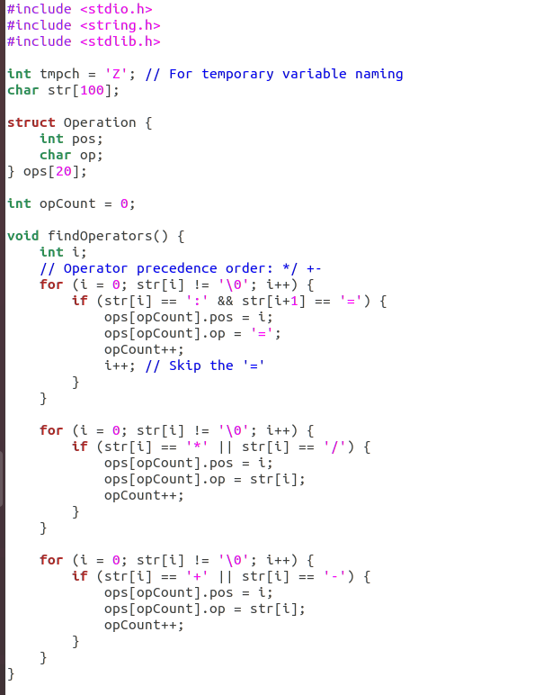

Sandesh Varma

CH.EN.U4CSE22078

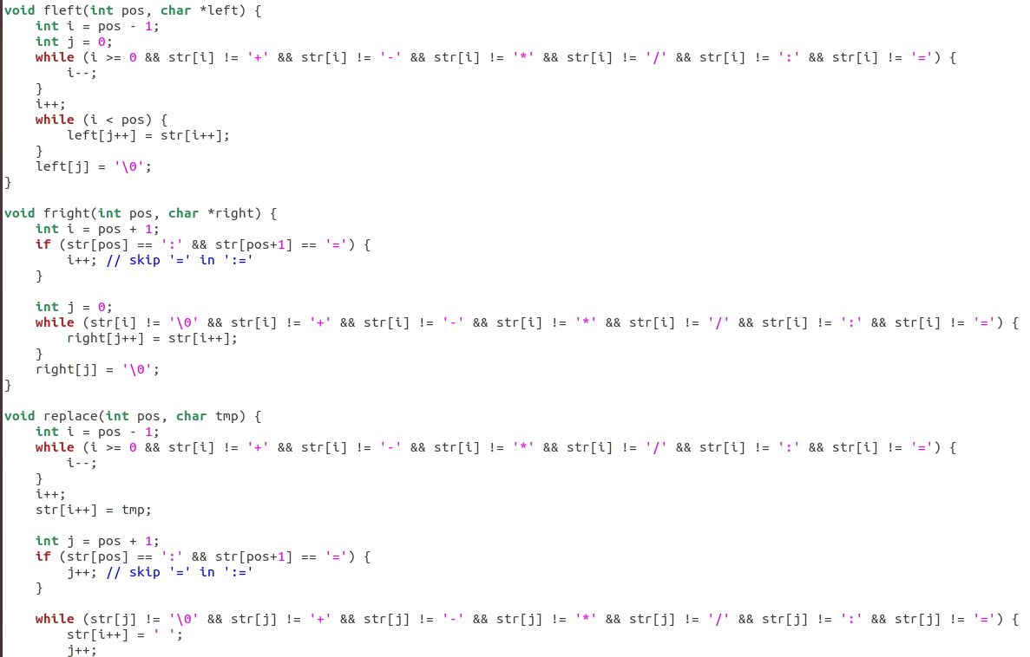

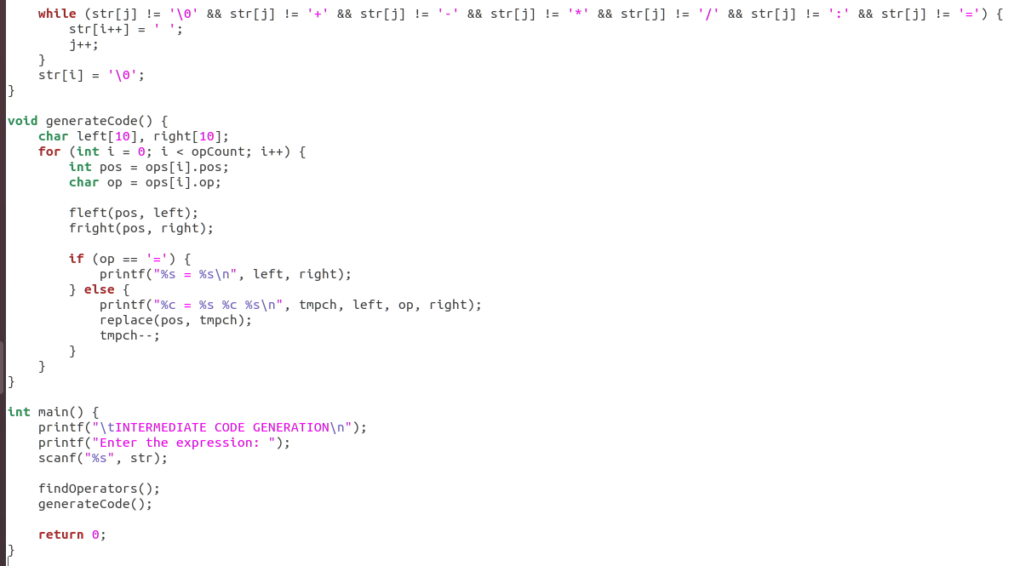

Output:

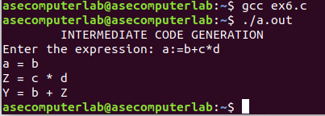

Results: The program for the implementation of intermediate code generation has been executed successfully.